3rd primary Second term 2016 / 2017 Aswan Gov
English Exam One hour and a half Edfu Educational Zone
===========================================================
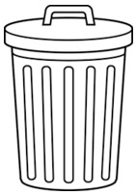
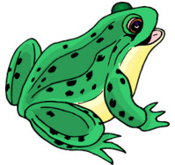
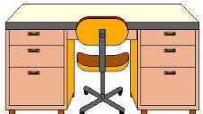
اسم الطالب : - رقم الجلوس :- ===========================================================
1 – Listen and number the pictures: : - (5M)

( ) ( ) ( ) ( ) ( )
2 – Listen and fill the gabs :- (4M)
A: - May I use the …………………………………..?
B: - Of ……………………………………
3 – Read and match A with B: - (4M)
( ) cake, please. | 1 – Does he
( ) likes bread. | 2 – pass the
( ) have glue? | 3 - Mona
( ) mess! | 4 – What a
( ) has paint?
4 – Choose the correct answer : - (5M)
1 – Ali …………………… a cold. ( don't have - doesn't - doesn't have )
2 – It's over ……………… (their - they - there)
3 – He ……………. chicken. (like – doesn't like – have)
4 – Where is the……….? (books – tables – pen)
5 – That's …………….. (my – mine – may)
5 – Look and unscramble the word:- (4M)
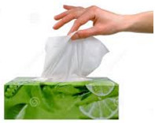 |  | 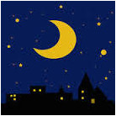
seusits | trwea | hintg | ssssicor
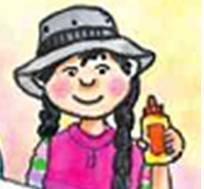
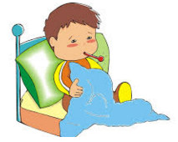
6 – Look and write a sentence : - (4M)

____________________________________________________________________________________________________________________________________________________________________________________________________________________________________________________________________________________7 - Punctuate the following sentence:- (2M)
he doesn't have a stomach ache
____________________________________________________________________________________________________________________________________________________________________________________________________________________________________________________________________________________
8 - Copy the following:- (2M)
1 – Where are you from?
____________________________________________________________________________________________________________________________________________________________________________________________________________________________________________________________________________________
2 – Sokkara likes salad.
____________________________________________________________________________________________________________________________________________________________________________________________________________________________________________________________________________________
انتهت الأسئلة ......... ................ مع أطيب الأمنيات بالنجاح والتوفيق

رقم السؤال | الاول | الثانى | الثالث | الرابع | الخامس | السادس | السابع | الثامن | النهائية
الدرجة النهائية | 5 | 4 | 4 | 5 | 4 | 4 | 2 | 2 | 30
درجة التلميذ

الرقم السري

Listening
1 – Listen and number the pictures: : -
1 – juice 2 – crayons 3 – desk 4 – bin 5 – toad
2 – Listen and fill the gabs :-
A: - May I use the (bathroom)?
B: - Of (course).

