Correlation

What is parsons correlation coefficient of ungrouped data?
Suppose that, we have a group of n persons and the following data are obtained from them for two variables x ,y
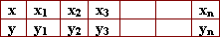
then pearson correlation coefficient (linear correlation coefficient) between x , y is defined as:
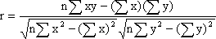

What are properties of the correlation coefficient?
1) If r > 0 then it is a direct correlation.
2) If r < 0 then it is an inverse correlation.
3) If r = 0 then no linear correlation.
4) If r = 1 then it is perfect direct correlation.
5) If r = -1 then it is perfect inverse correlation.

If we subtract any constant from all values of the first variable and any constant from all values of the other variable then its value does not change.
If we add any constant to all values of the first variable and any constant to all values of the other variable then its value does not change.

Compute pearson's correlation coefficient for the following data on mathematics (1) and Mathematics (2) of a group of 10 students then determine its type.
Let x denote the marks for mathematics (1)
Let y denote the marks for mathematics (2)
We construct the following table:
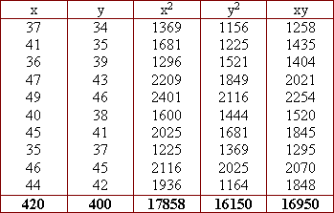

What happens, if we subtract a constant number from all values of the first variable and also a constant number from all values of the second variable?
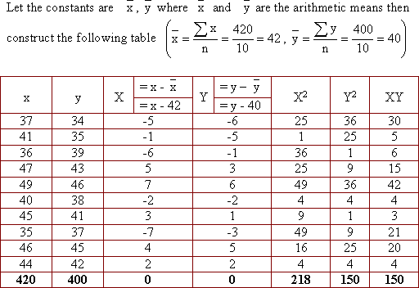
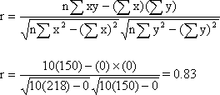
It is the same result obtained before, but with easier calculation.

Choose the correct answer:
a) If r is the linear correlation coefficient between the two variables x and y then
b) The correlation is direct if its coefficient
(r = 0 , r > 0 , r < 0)

In a study concerned with the relation between two variables x,y , it was found that:
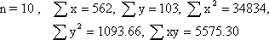

Find the correlation coefficient between x,y state its type.
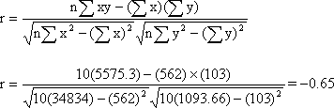
It is an inverse correlatio

In a study concerned with the relation between two variables x,y , it was found that:
Find the correlation coefficient between x, y. state its type.
r = -1. It is a perfect inverse correlation.

A sample consists of 12 workers is selected to study the relation between the income y and the age x the following data are obtained:
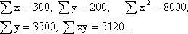
Find the correlation coefficient between the income and the age and state its type.
r = 0.4 , it is a direct correlation.

Compute Pearson's correlation coefficient for the following data between x and y showing its type.
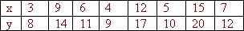
r = 1 it is a perfect direct correlation.

In studying the relation between the demanded quantity "x" of certain commodity and its price "y" the following data are obtained:
Find the linear correlation coefficient between the demanded quantity and the price.
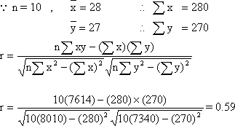

What is spearman's rank correlation coefficient?
It is one of the approximated measurments to determine the correlation coefficient between variables.
It depends on ranks and not on the values of the variables.
It determine the correlation coefficient between descriptive data.

What is the relation of spearman's rank correlation coefficient?
The relation is
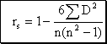
where "D" is the differences between ranks of corresponding values of the variables.
"n" is the number of pairs of values in the data naturally, there will be a difference between the two values of the correlation coefficient of the original values and its rank correlation coefficient.

The following table gives the grades of 7 students in mathematics and statistics. Calculate the correlation coefficient for the grades in the two subjects and determine its type.
It is clear that we cannot determine pearson's correlation coefficient of this qualititive data.
Then we calculate spearman's rank correlation coefficient of this data as follows:
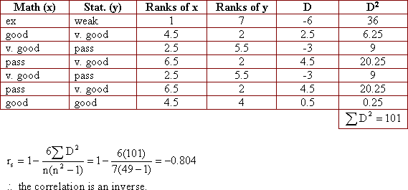

Calculate spearman's rank correlation coefficient between x, y of the following table and determine its type.
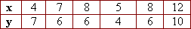
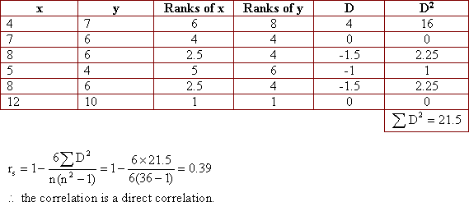
If you find r for pearson, you notice that there is a difference between pearson's correlation coefficient and spearman's rank correlation coefficient.

The following table shows the age in weeks and the height in centimeters of a plant. Find spearman's rank correlation coefficient between the age and the height.
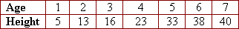
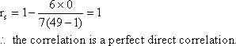
Find "r" for pearson's then compare between the results.
How many forms for the scattering diagram?
The scattering diagram can be found in many forms depending on the relationship between the two variables
1) These figures show the perfect correlation between the two variables. All the points lie on a striaght curve. :
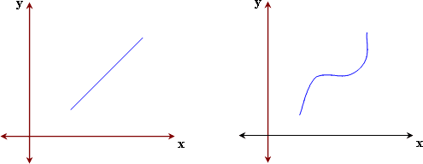
2) This figure shows the zero correlation between the two variables where the points are scattered in the plane without any relation between them..
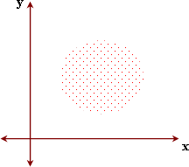
3) This figure slows that:
there is a direct correlation between the two variables.
They increase or decrease together.
The correlation coefficient is positive.
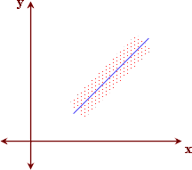
4) This figure shows that:
- there is an inverse correlation between the two variables.
- The correlation coefficient is negative.
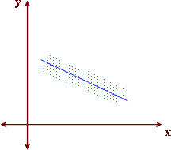
This line is called the regression line.

