If X is normally distributed with = 50 and variance 100 Find:
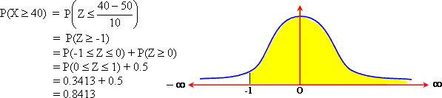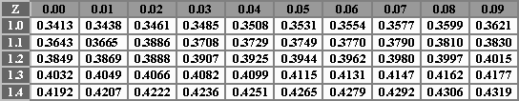

If X is normally distributed with = 50 and variance 100 Find:
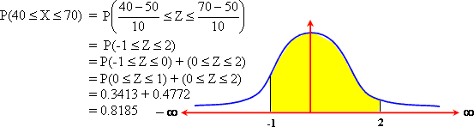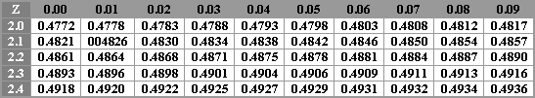

If X is normal random variable with mean and standard diviation , Find:
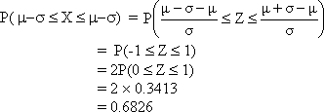
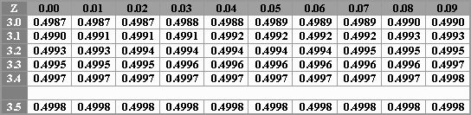
this means that 68.26% from the total area under the normal curve lies above the Interval [ - , + ]

If X is normal random variable with mean and standard diviation , Find:
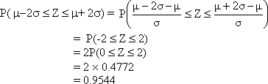
This means that 95.44 % from the total area under the normal curve lies above the interval Interval [ - 2 , + 2 ]

If X is normal random variable with mean and standard diviation , Find:
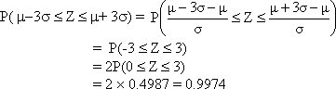

If X is normal random variable with mean and standard diviation , Find:
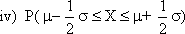
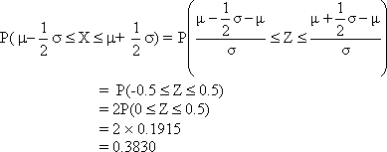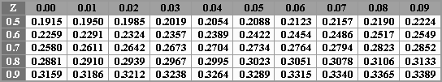

If X is normal random variable with mean and standard diviation , Find:
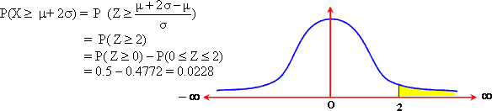

If X is normal random variable with mean and standard deviation , Find k , such that
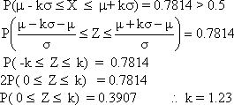

If X is normal random variable with mean and standard diviation , Find k , such that
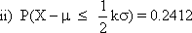
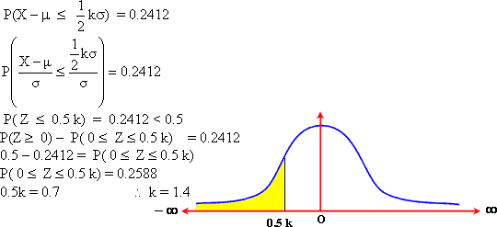

If X is normal random variable with mean and standard diviation , Find k , such that
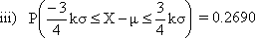
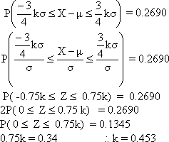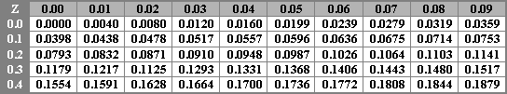

If X is normal random variable with mean and standard diviation , Find k , such that
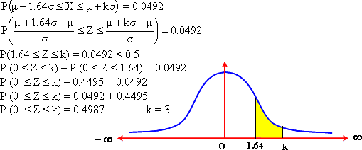

1000 youth submitted in the armed forces. If their heights are normally distributed with mean 170 cm, and standard deviation 10 cm. Find the number of youth:
i) whose heights are less than 190 cm.
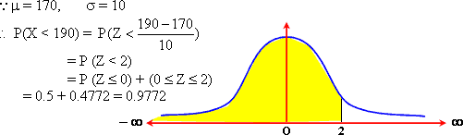
number of youth whose heights
are less than 190 cm = 0.9772 × 1000 977

1000 youth submitted in the armed forces. If their heights are normally distributed with mean 170 cm, and standard deviation 10 cm. Find the number of youth:
ii) unaccepted if the minimum required height is 155 cm.
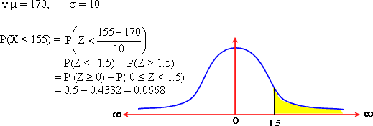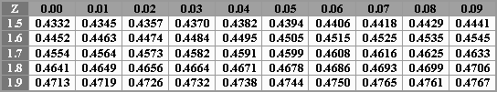

1000 youth submitted in the armed forces. If their heights are normally distributed with mean 170 cm, and standard deviation 10 cm. Find the number of youth:
iii) whose heights lie between 160 cm , 180 cm
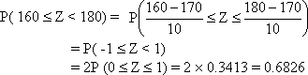
the number of youth whose heights lie
between 160 cm and 180 cm = 0.6826 × 1000 683

1000 youth submitted in the armed forces. If their heights are normally distributed with mean 170 cm, and standard deviation 10 cm. Find the number of youth:
iv) whose heights are more than 2 m
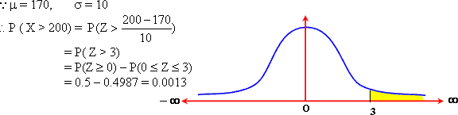
BR>
number of youth whose heights are more than 2 m = 0.0013 × 1000 1

* 1000 youth submitted in the armed forces. If their heights are normally distributed with mean 170 cm, and standard deviation 10 cm. Find the number of youth:
v) whose heights are more than 170 cm.
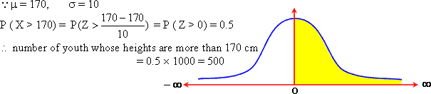

1000 youth submitted in the armed forces. If their heights are normally distributed with mean 170 cm, and standard deviation 10 cm. Find the number of youth:
vi) The percentage of youth whose heights are more than 170 cm.

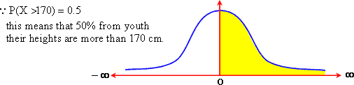

The weights of students in a college are normally distributed with mean = 68 kg and variance 16 kg ² Find:
i) Probability that the weight of a student is greater than 70 kg.
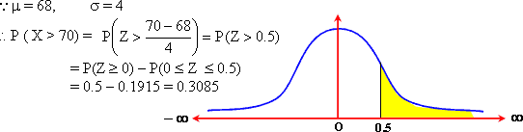

The weights of students in a college are normally distributed with mean = 68 kg and variance 16 kg ² Find:
ii) the percentage of students whose weights lie between 65 kg, 72 kg
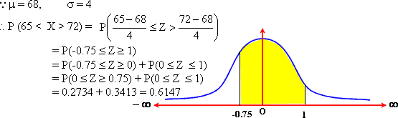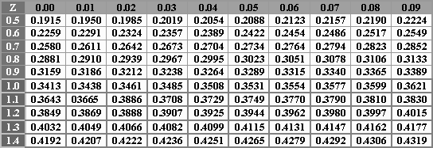

The weights of students in a college are normally distributed with mean = 68 kg and variance 16 kg ² Find:
iii) the number of students whose weights are greater than 66 kg if the number of students in the college 2000. 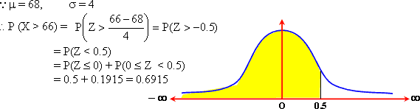

The weights of students in a college are normally distributed with mean = 68 kg and variance 16 kg ² Find:
iv) the percentages of students whose weights are less than 68 kg.
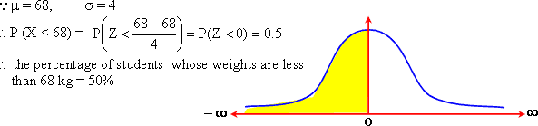

*The weights of students in a college are normally distributed with mean = 68 kg and variance 16 kg ² Find:
v) the percentages of students whose weights are less than 64 kg.
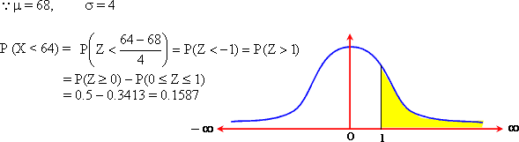

let X is a normal random variable with mean and standard deviation 5. Determine the value of
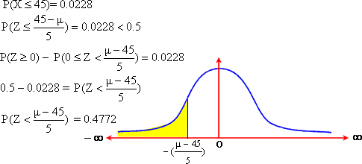

let X is a normal random variable with mean and standard deviation 5. Determine the value of .
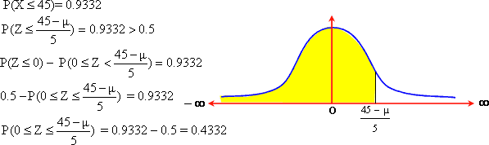

let X is a normal random variable with mean = 55 and standard deviation 5. Find the value of k if
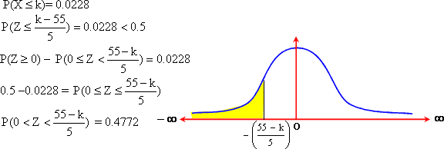

let X is a normal random variable with mean = 55. Find the value of if
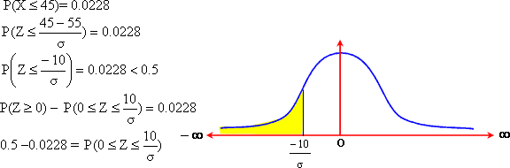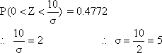

Suppose the marks for an examination are normally distributed with mean 75 and standard deviation 15. The top 15% of the students receive an excellent estimate. Find the minimum mark a student must get in order to receive this grade. 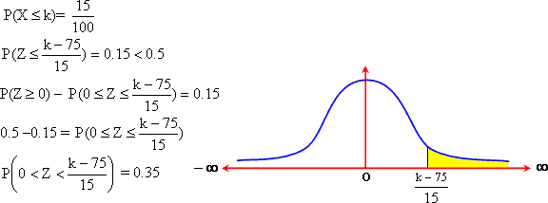

The heights of certain plant are normally distributed with mean 60 cm and standard deviation . If the heights of 1.22% from this plant are less than 51 cm. Find the standard deviation of the heights distribution.
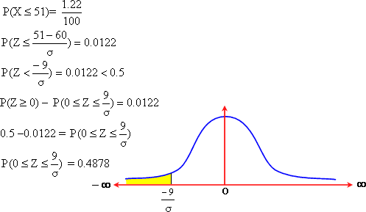

If X is a normal random variable with mean and standard deviation . Find , given that.
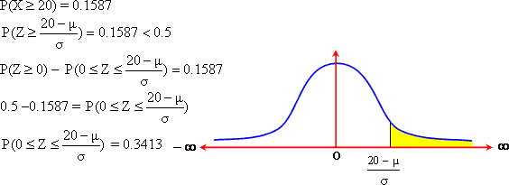

2 factories A, B produce batteries. The mean of the life – time of the batteries produce in A is 18 hours with standard deviation 1.25 hours. The mean of life of those produces in B is 20 hours with standard deviation 1.75 hours. The batteries ages produced in the two factories, are normally distributed. Which factory produces better, knowing that the battery whose life – time is 15 hours is bad and refused.
