Probability
Determine the sample space of each of the following experiments and find the number of outcomes in it.
a) Tossing a coin and observing its apparent face.
b) Tossing a die and observing the number appearing on the upper face.
c) A family has one child (with respect to sex).
d) Match of football of ALAHILY club (with respect the result).
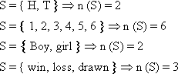
Determine the sample space of each of the following experiments and find the number of outcomes in it.
a) Tossing a coin twice or tossing two distinct coins simultaneously and observing the apparent faces
b) Tossing a coin three times or tossing three distinct coins simultaneously and observing the apparent faces.
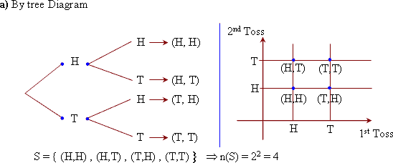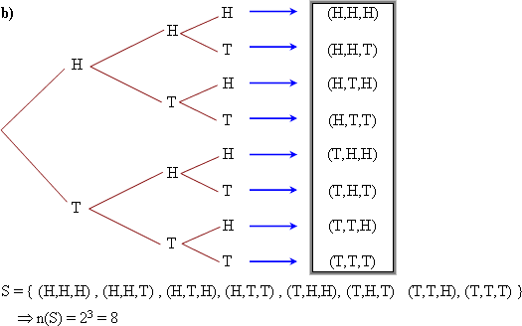

Determine the sample space of each of the following experiments and find the number of outcomes.
a) Tossing a die once and observing the upper face.
b) Tossing a die two consecutive times and observing the number on the top face each time. 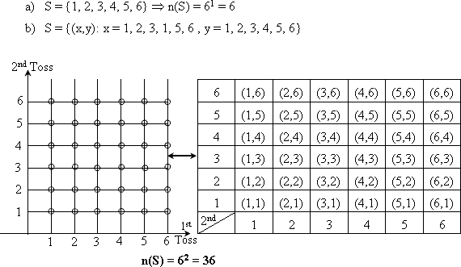
An experiment consists of tossing a die end then flipping a coin once. Describe the sample space and find the number of outcomes.
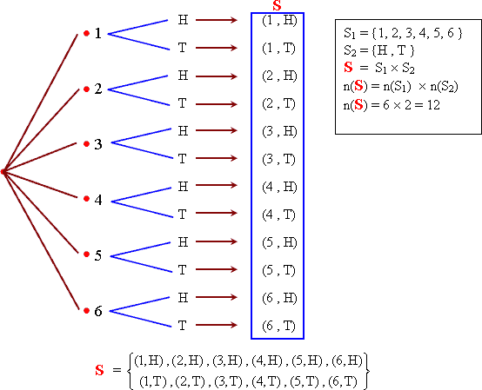
An experiment consists of flipping a coin and then flipping it a second time if a head occurs. If a tail occurs on the first flip, then a die is tossed once. List the elements of the sample space.
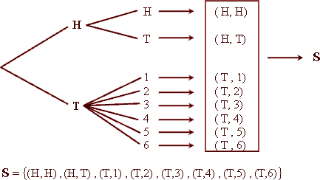

One card is selected at random from 10 cards numbered 1 to 10 write down the sample space.

A box contains 4 cards numbered: 1, 2, 3, and 4. Two cards are drawn randomly as follow
a) one after another with replacement.
b) one after another without replacement.
Write down the sample space in each

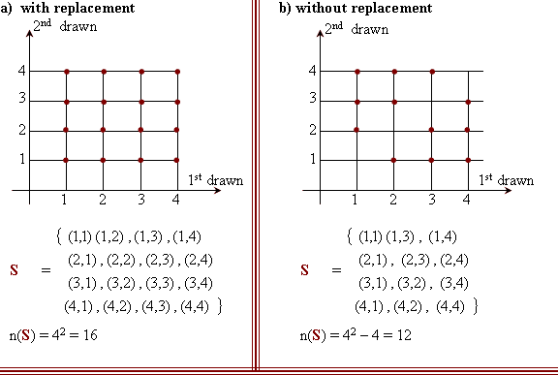
A box contains 3 balls, they are white, red and black
a) a ball drawn randomly write down its sample space.
b) Two balls are drawn randomly with replacement.
Write down its sample space.
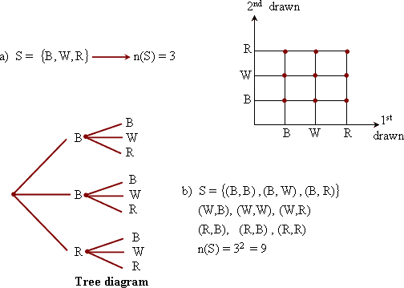
In the experiment of tossing a single die and observing the number on the upper face write down the sample space of the experiment and determine the following events.
A = the event of getting an even number.
B = the event of getting a number divisble by 3
C = the evet of getting a number greater than 6
D = the event of getting a number x , which satisfies the inequality E = the event of getting a number x, which satsifies the inequality 3 < x < 5
Then show which of them is sure event, impossible event and simple event.
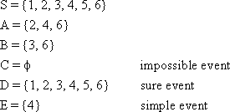
When a coin is tossed twice and the faces showing are observed. Determine each of the following events:
A = the event of the appearance of exactly one head.
B = the event of the appearance of at least one head.
C = The event of the appearance of at most one head.
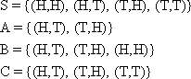

In the experiment of tossing a die and observing the number on the upper face. Let A be the event of getting even number and B be the event of getting odd number show that A, B are mutually exclusive events.
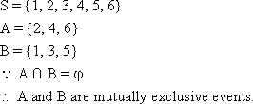
In the experiment of tossing a die and obseving the number on the upper face. Determine each of the following events:
A = getting an even number
B = getting an odd number
C = getting a number divisible by 3
Determine which pair of the events A, B, C are mutually exclusive and whether the three events are mutually exclusive.
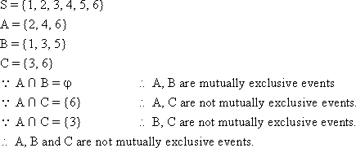
In the experiment of tossing a single die twice represent the sample space S. Determine the following events:
A = the event of getting two equal numbers.
B = the event of getting the sum of two numbers is 9.
Are the two events mutually exclusive?
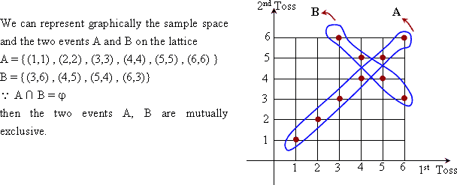
In the experiment of tossing a single die twice, represent the sample space S graphically, then determine the following events
A = the event of getting two numbers whose sum is 6.
B = the event of getting two numbers whose sum is less than 6.
C = the event of getting two numbers whose sum is greater than 6.
Are the events A, B, C mutually exclusive?
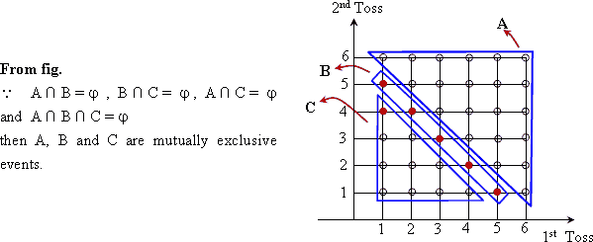
One card is selected at random from 40 cards numbered from 1 to 40. Determine each of the following events
A: the event of getting an odd number divisible by 5
B: the event of getting an odd number divisible by 7
C: the event of getting an odd number and divisible by 5 and 7
D: the event of getting an odd number and divisible by 5 or 7
E: the event represent the card carries an odd number and divisible by 5 only
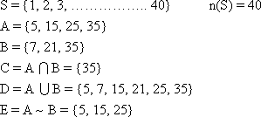
A box contains 4 cards numbered: 1, 2, 3 and 4. Two cards are randomly drawn one after the other without replacement. Write the sample space of this experiment then determine the following events.
A: the event of getting an odd number in the first drawing.
B: the event of getting sum of th two numbers is divisible by 3 , then find
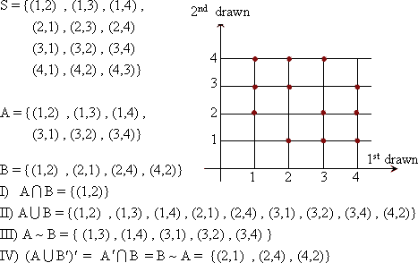
In the experiment of tossing a die twice. If A is the event of getting the number 4 in any toss, B is the event of getting two numbers such that their sum is 6. Find:
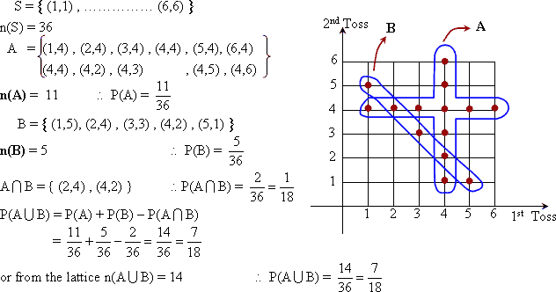
) The set = { 2, 3, 4, 5, 6 } is used to form a 2 different digit number. Find the probability of the following events :
i) The tens digit is odd
ii) the unit digit is prime
iii) the tens digit is odd or the unit digit is prime.
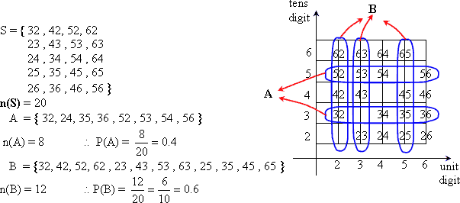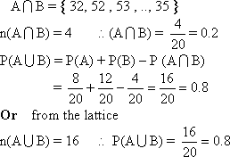
Two players A and B shoot in a target in the same time. The probability that the player A hit the target is , the probability that the player B hit the target is and the probability that both A and B hit the target is . Find:
i) the probability of hitting the target.
ii) the probability that B only hit the target.
