Random Variable
A die is tossed two consecutive times to observe the number appearing on its upper face. If the event A is appearing of a number in the second toss greater than that of the first. B is the event of appearing two numbers such that their sum is less than 7. Find each of
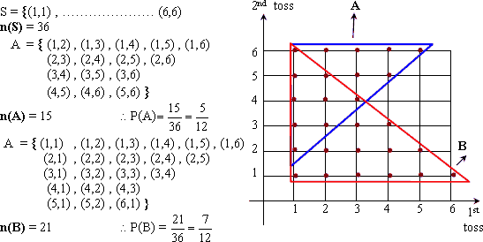
If A and B are two events in the sample space S of a random experiment such that
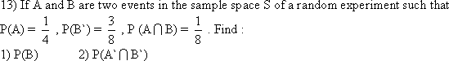
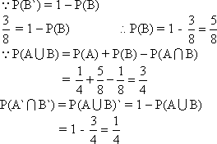
A box contains 5 red balls, 6 white balls, 4 black balls and only one green ball.
A ball is chosen at random from the box. Find the probability that :
A: the chosen ball is red.
B: the chosen ball is white
C: the chosen ball is white red
D: the chosen ball is not black
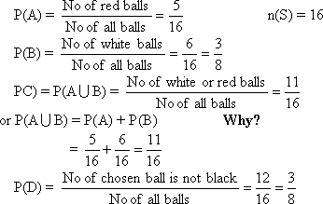
In one of the youth houses it was found that it contains 20 persons. 5 of them are from Egypt, 8 of them from Germany, 4 of them from Japan. And 3 of them from U.S.A. A person is chosen at random, what is the probability that the person is from.
i) Japan ii) U.S.A iii) Egypt or Germany
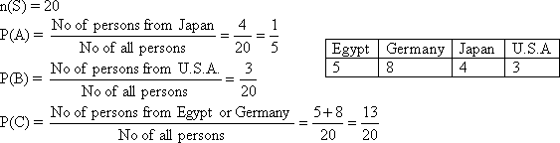
A die is designed such that it carries numbers from O to 5. If the die is tossed twice and the number on the face up is observed in each time.
i) Write down the sample space
ii) find the probability that the Sum of the scores is 8
iii) find the probability that one of the two appeared numbers is 4 and their sum is greater than 7.
iv) Find the probability of getting two different numbers and their sum is greater than 9 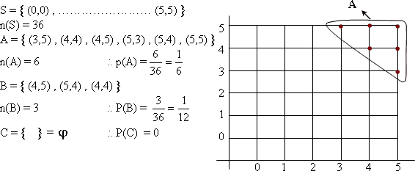

A set of 100 persons, 60 of them speak English, 45 speak French and 15 speak English and French together. One person is chosen randomly. Find the probability that the chosen one
i) Does not speak any of the two languages.
ii) Speak English or French
ii) Speak only one language.
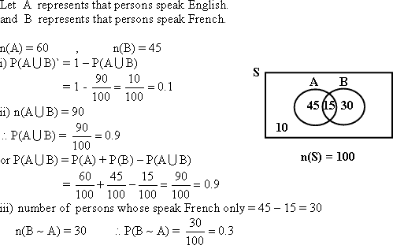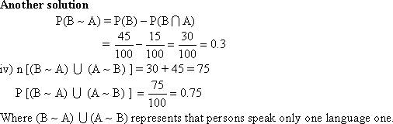
If A and B are two mutually exclusive events in a sample space of random experiment, and
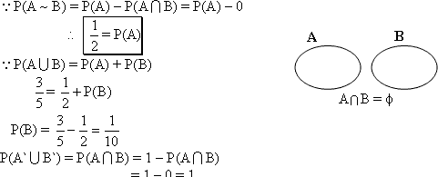

If A and B are two events in a sample space S of a random experiment and
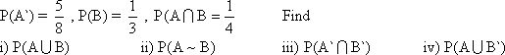
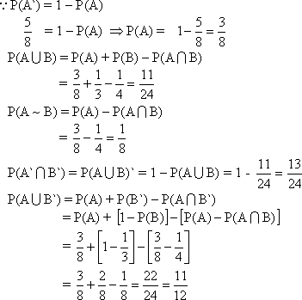
The number of visitors in an exhibition in a certain day is 100 visitors and they are classified as shown in the given table. If one visitor is chosen randomly find the probability that the chosen one is
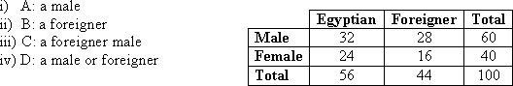
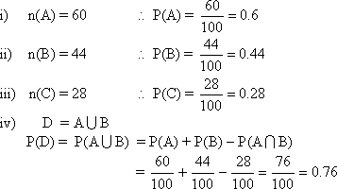
A die is designed such that the probabilities of the appearance of the odd numbers are equal and the probabilities of the appearance of the even numbers is twice the probability of the appearance of the odd one. Find the probability of the appearance of each of the six faces of the die then find the probability of:
1) The event of getting a prime number
2) The event of getting a number 3
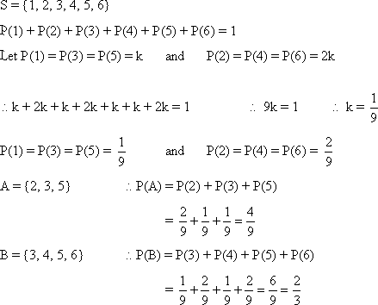
A bag contains 25 identical cards, labeled from 1 to 25, A card is drawn randomly from the bag. Find the probability that the label number on the drawn card is:
i) an odd number. ii) an odd number or divisible by 3
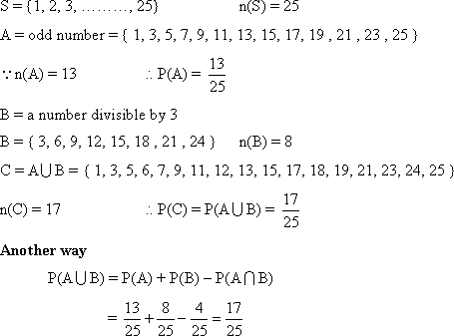
Giva a summary in a table represented each of : events, Symbol, Graphical representation and its probabilities.
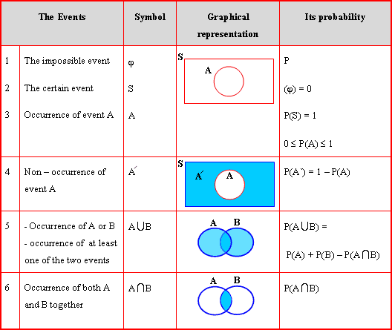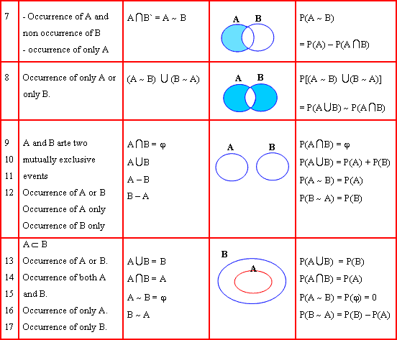

A coin is tossed twice, let the random variable X denote "the number of heads - the number of tails" Find the range.
To find the range of the random variable, you have to follow the following steps:
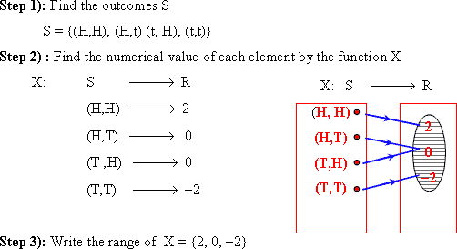
A die is tossed twice. Let the random variable X denote "the sum of the two numbers that apear" find the range of the random variable.
S = {(1,1) , (1,2) , (1,3) , … (6,6)} , The range of X = {2, 3, 4, ………… 12} and it is a discrete random variable.
Two boxes, each of them contains three balls are numbered from 1 to 3. A ball is chosen at random from each box, the random variable X denotes "the sum of the two numbers on the two selected balls". Find the range of X
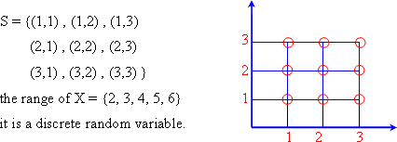
State which of the following functions could not determine the probobility distrubution of a random variable X , its range is {0, 1, 2, 3}
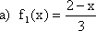
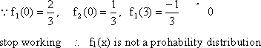

State which of the following functions could not determine the probobility distrubution of a random variable X , its range is {0, 1, 2, 3}
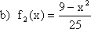
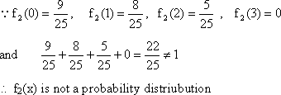
State which of the following functions could not determine the probobility distrubution of a random variable X , its range is {0, 1, 2, 3}
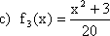
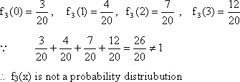
State which of the following functions could not determine the probobility distrubution of a random variable X , its range is {0, 1, 2, 3}
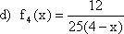
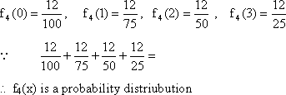
Let "x" be a discrete random variable, its range is {0, 1, 2, 3, 4} and P(x = 0) = 0.1 , P(x = 1) = 0.15 , P(x =2) = 0.2 , P( x = 3) = 0.25 and P (x = 4) = m. Find the probability distribution of X.
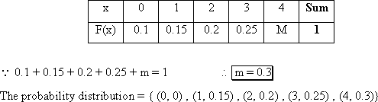
A discrete random variable X has a probability distribution determined by the function
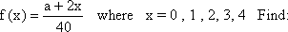
1) the value of a
2) P(x = 3 or x = 0)
3) the probability distribution of X.
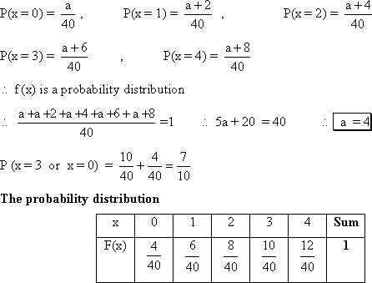
A box contains 5 balls numbered from 1 to 5, two balls are drawn randomly. If X is defined as "the sum of the two numbers which appear on the two selected balls. Find the probability distribution of X if the two balls are drawn
a) with replacement
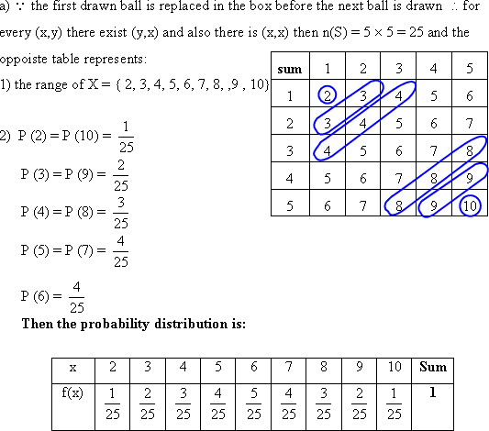
A box contains 5 balls numbered from 1 to 5, two balls are drawn randomly. If X is defined as "the sum of the two numbers which appear on the two selected balls. Find the probability distribution of X if the two balls are drawn
b) with out replacement
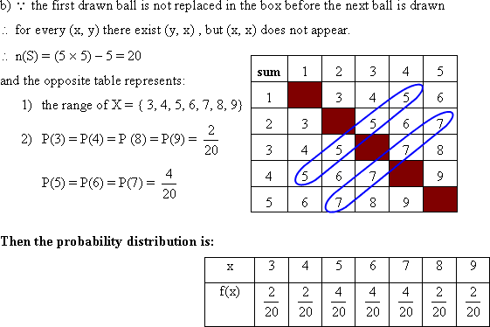
A box contains 5 balls numbered from 1 to 5, two balls are drawn randomly. If X is defined as "the sum of the two numbers which appear on the two selected balls. Find the probability distribution of X if the two balls are drawn
c) together
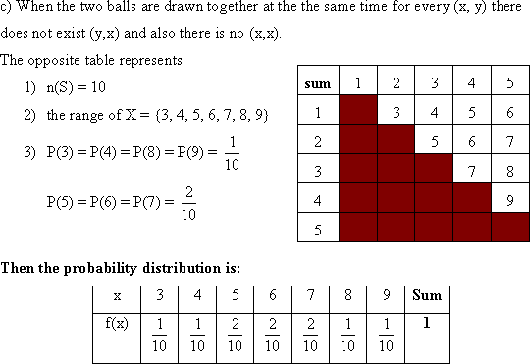
If X is a discrete random variable, its range is {1, 3, 5, 7} and P(x = 1) = k ,
Find the value of k then write the probability distribution of X.
