Let X be a discrete random variable, its range is {0, 1, 2} such that for every
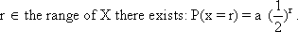
Find the value of a, then write the probabtility distribution.
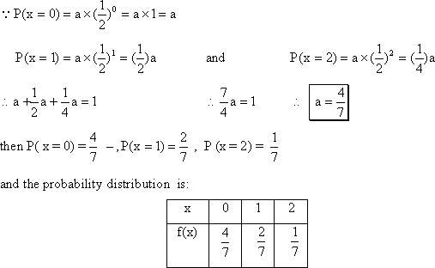
If the mean of a random variable equals 16 and the coefficient of variation equals 6.5%. Find the variance.
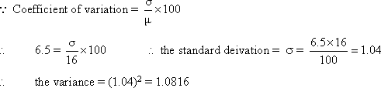
18) Let X be a discrete random variable with the following probability distribution.
Find:
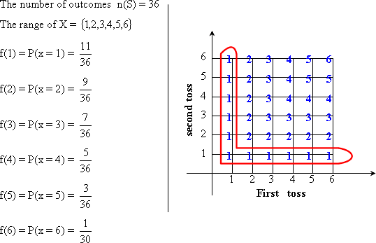
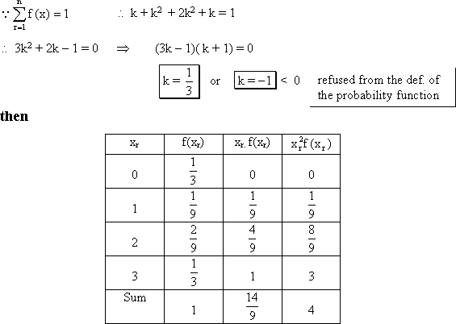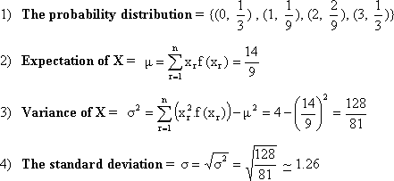
Adie is tossed twice. Let the random variable X denote "the minimum of the two numbers that appear" Evaluate the variance of X and its coefficient of variation.
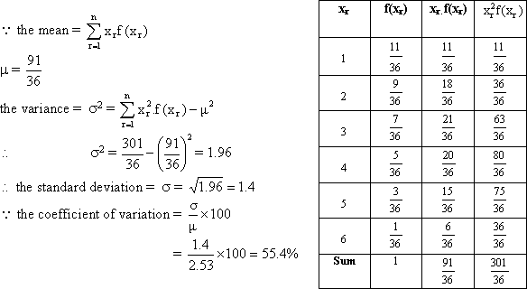
Let X be a discrete random variable its range is {0, 1, 2, 3}. The probability distribution is given by the function 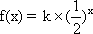
Find k then calculate the standard deviation of X.
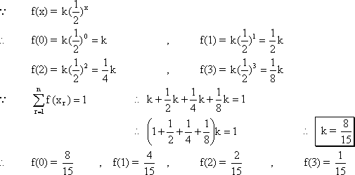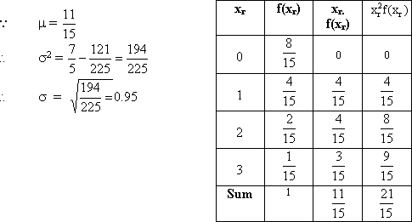
Let X be a discrete random variable its range is {4, 6, 8,} and its expectation is 7,
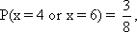
calculate the coefficient of variation. 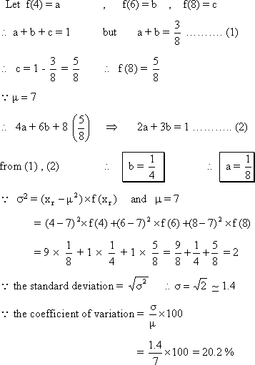
If the mean of a random variable is 5 and its coefficient of variation is 80%. Find the variance of this variable.
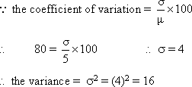
If the mean of a random variable is 25 and its variance is 49. Find the coefficient of variation of the random variable.
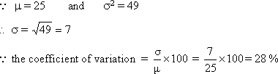

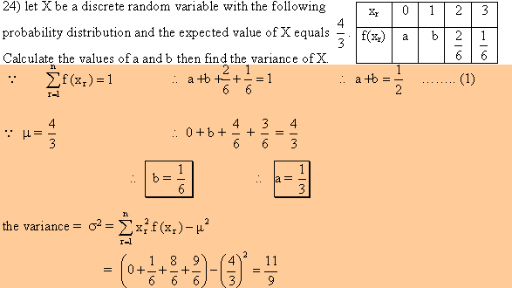
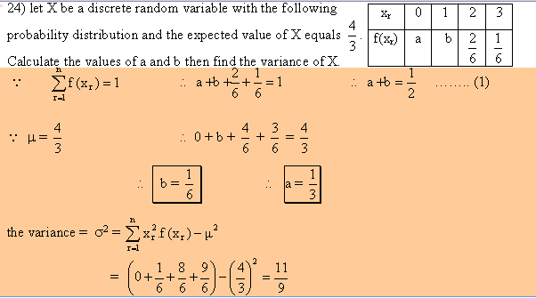

A discrete random variable X has a probability distribution determined by the function
where x = 0, 1, 2 and 3 find:
i) the value of a
ii) p(x = 1 or x = 3)
iii) the mean of X
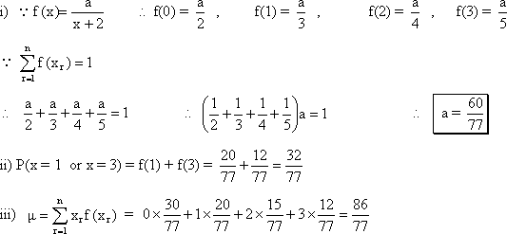
What is the continuous probability distribution?
The range of a continuous random variable is an open or closed interval, therefore we will be interested in probability that the continuous random variable lies in a subinterval of its range
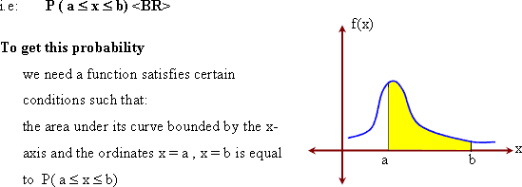
Let X be a continuous random variable with the following density function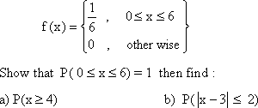
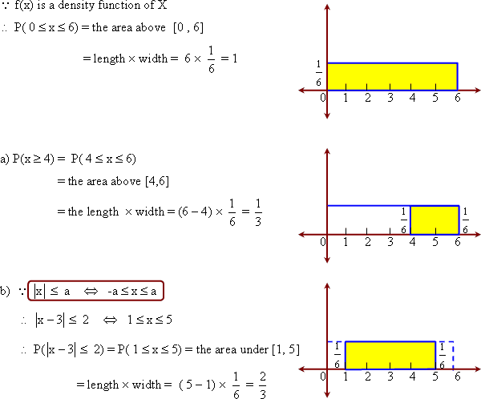
If f is a function where
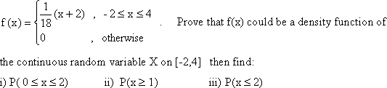
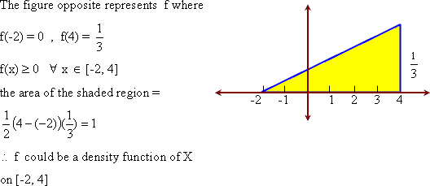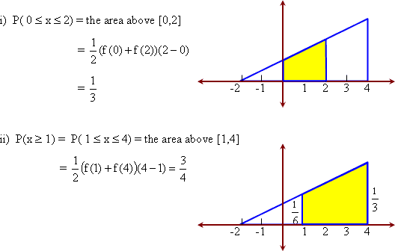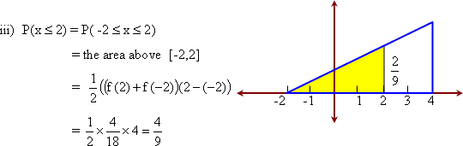
Let X be a continuous random variable with the following density function
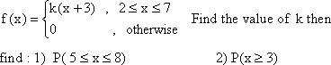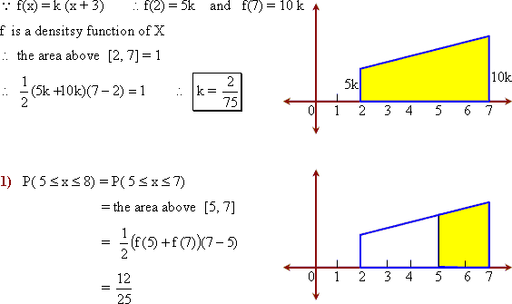
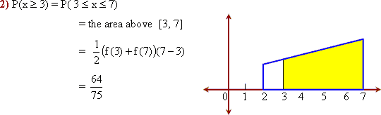
Let X be a continuous random variable with the following density function
