Regression
What is the regression line y on x ?
Suppose we want to fit a straight line which represents the regression line of y on x
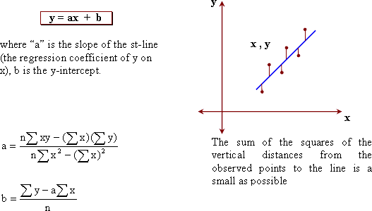

) The following table shows the income and the consumption of 7 families in a certain city.
Find: i) the regression line of consumption on the income.
ii) an estimate for the consumption when the income equals 45. -We can construct the following table:
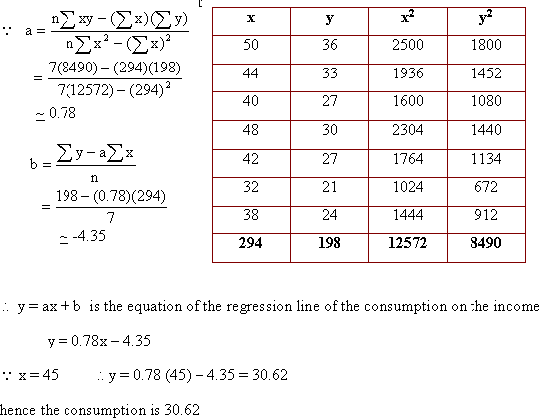

The following table shows the relation between x and y.
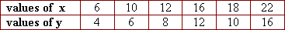
Find: i) the regression line of x on y.
ii) an estimate value of x when y = 7
- We can construct the following table:
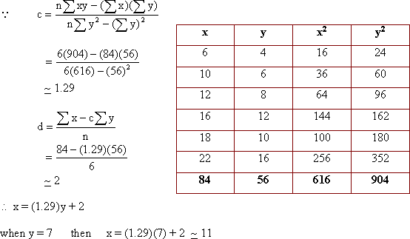
Are there simple methods to find the regression lines?
We notice that the calculation are complicated so we can simplify these calculations by using one of the following methods.
a) The deviations method:
let X = x - h , Y= y - k where h, k are two arbitrary constants.
Hence, we find the equation of regression line of Y on X, then we find the equation of regression line of y on x
b) The simplified deviations method:
h, k , i, m are arbitrary constants.
Hence we find the regression line of
then we find the regression line of y on x

Find the regression line of the consumption on the income for the following date using the deviations method
Let X = x - 40 , Y = y - 27 . We construct the following table:
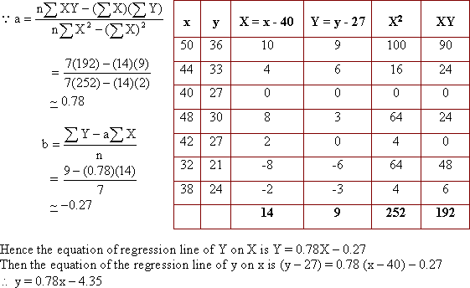

Find the equation of regression line of consumption on income using the simplified deviations method from the following data.
We construct the following table:
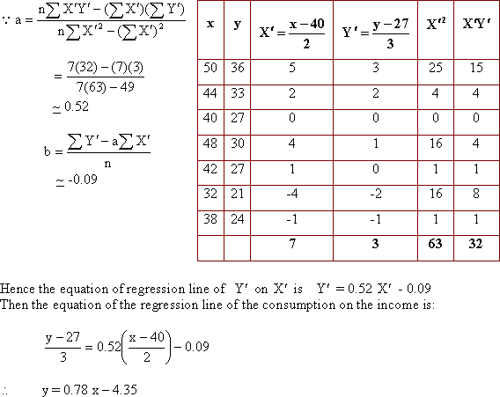
What the relation between the regression coefficient and the correlation coefficient?
The proudct of the regression coefficient of y on x and the regression coefficient of x on y is equal to the square of the correlation coefficient.
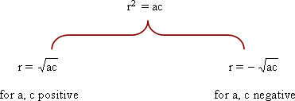

In studying the relation between the two variables x and y, if the equation of the regression line of y on x was y = 0.421x + 0.67. The equation of the regression line of x on y was x = 1.58y + 3.9. Find the linear correlation coefficient between x and y and determine its type.
If the regression coefficient of y on x is -3.2 and the linear correlation coefficient regression between x and y is -0.8. Find the regression coefficient of x on y.
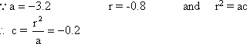
If the regression coefficient of x on y is -0.25 and the regression coefficient of y on x is -0.81.
Find the linear correlation coefficient between x and y and determine its type.
From the following table
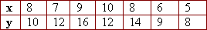
Find:
i) the regression coefficient of y on x.
ii) the regression coefficient of x on y.
Hence, find the linear correlation coefficient between x and y.
